**Import ZIP to DSpace 6.X**

**Rustam Eyniyev (ASOIU)**

First, we sign in as a dspace user via the command prompt

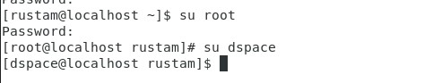

Then we create the xmlui.xml file:



We write the following into the file:

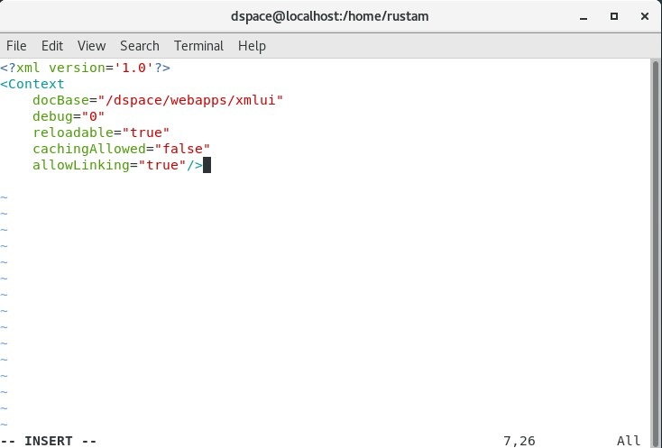

Now we launch Tomcat

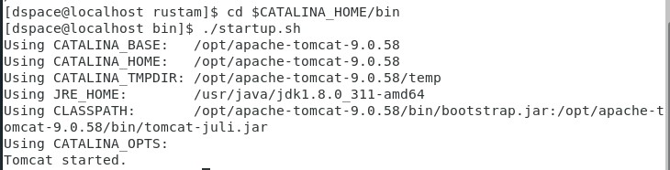

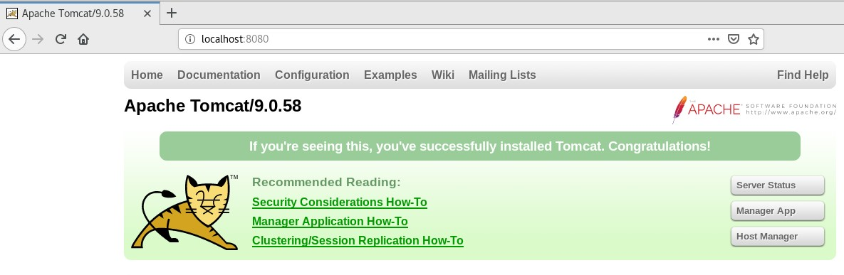

Next we enter dspace through localhost:8080/jspui

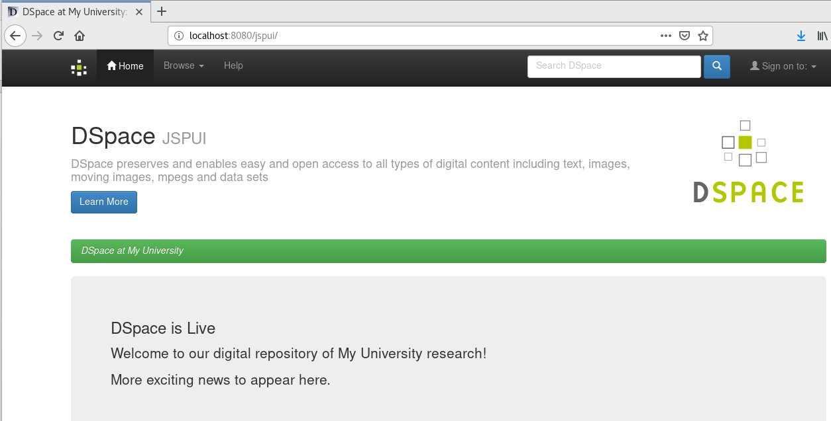

We sign in to our dspace account

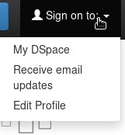

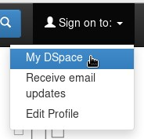

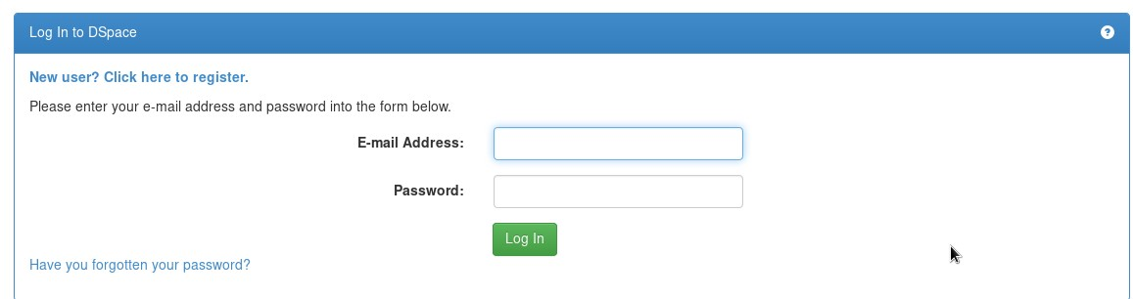

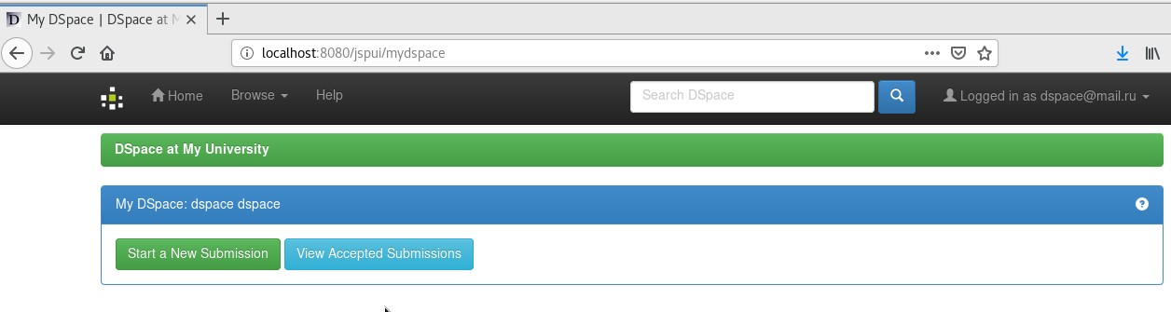

We choose the “Administer” option

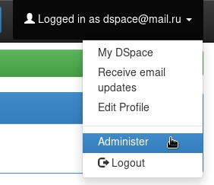

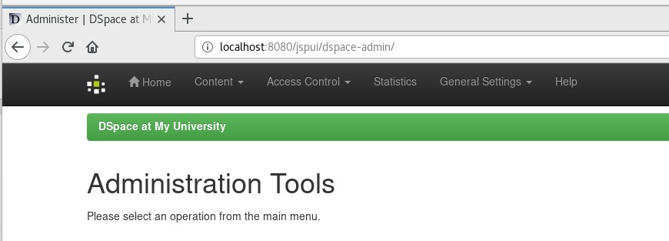

Now we go to Content > Communities & Collections

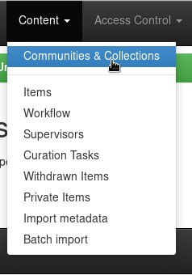

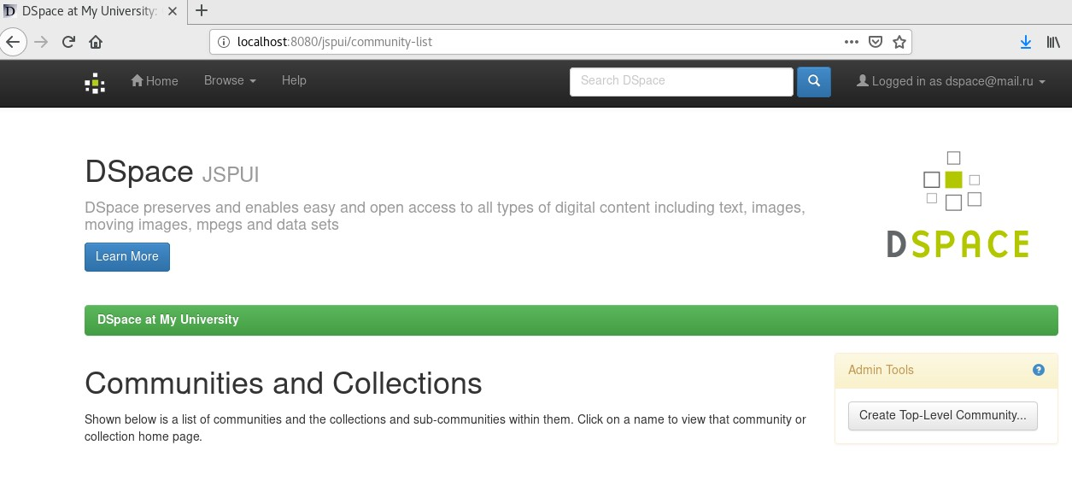

In order to create a new Community we click on “Create Top-Level Community”

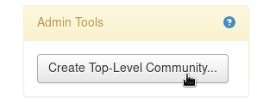

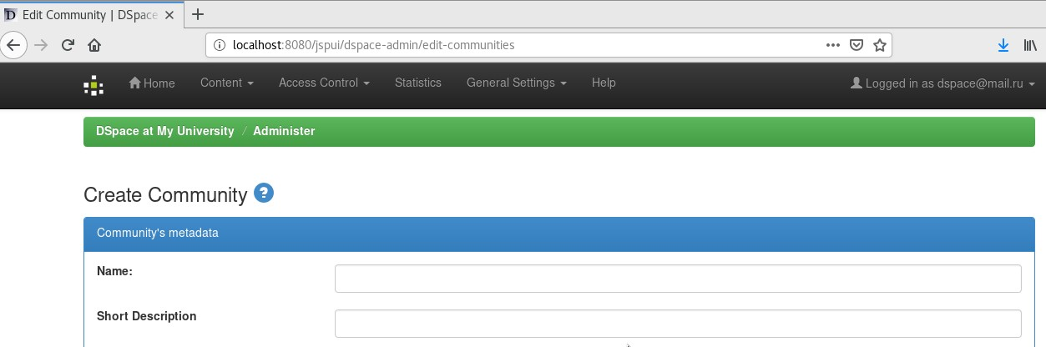

We type an arbitrary name (you may fill in the other fields as well if you want) and click “Create”

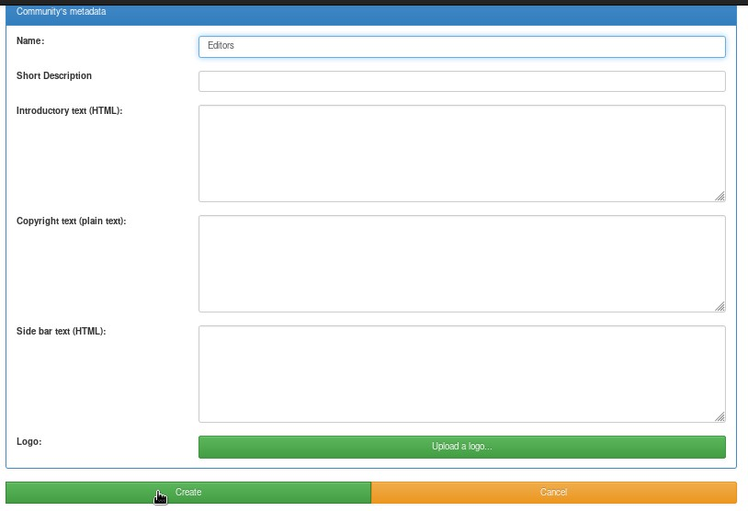

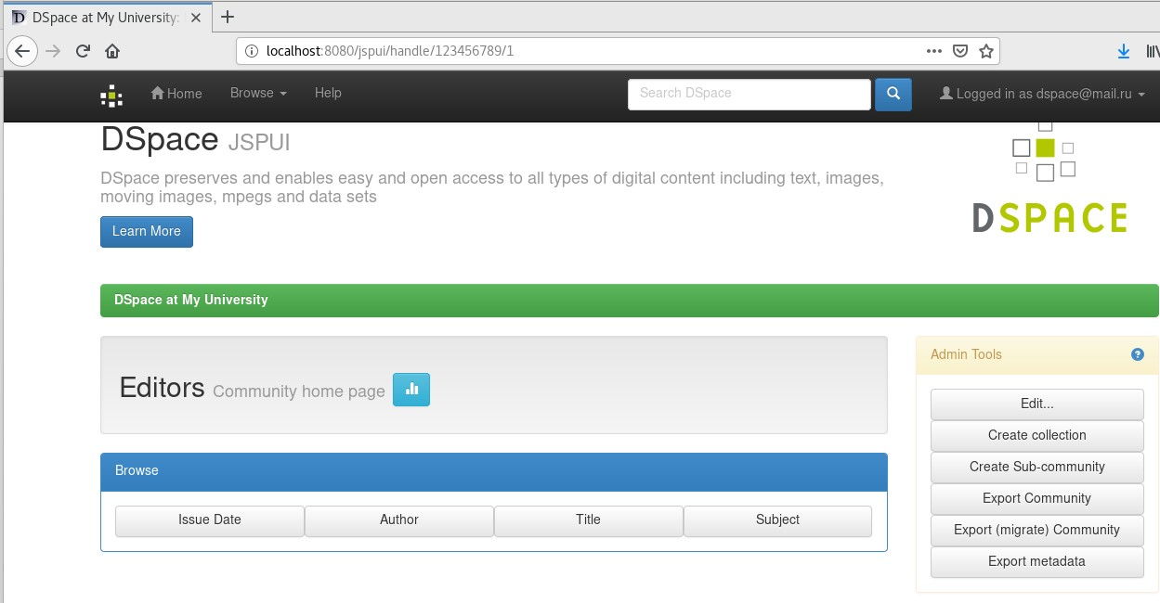

Here we create a Collection by clicking “Create collection”

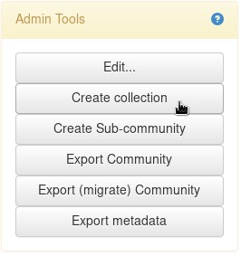

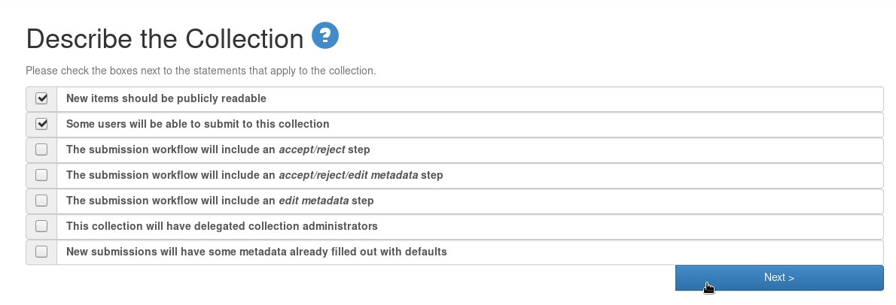

We enter a name for the Collection (you may fill in the other fields as well if you want) and click Next

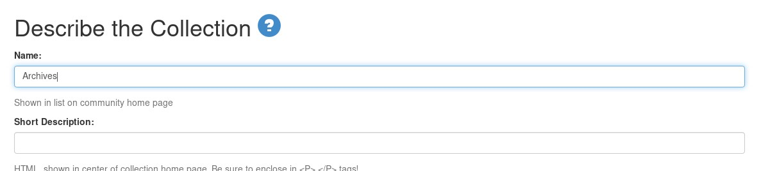

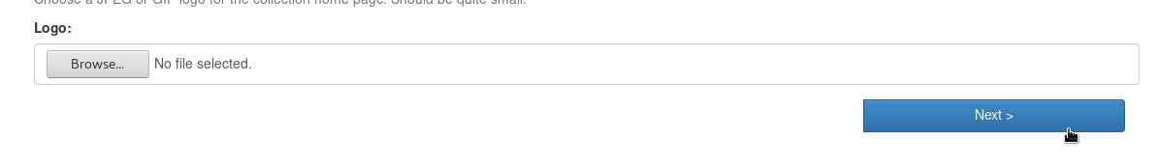

Next we select the e-people and the groups, that will have access to this Collection

1. We begin with e-people

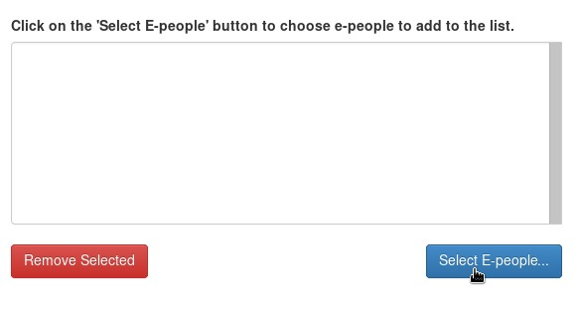

We click “add” for the needed user and manually close the newly-appeared window.

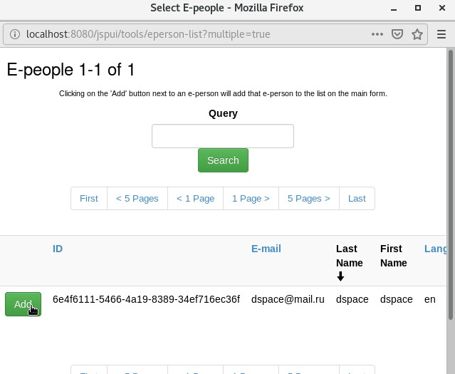

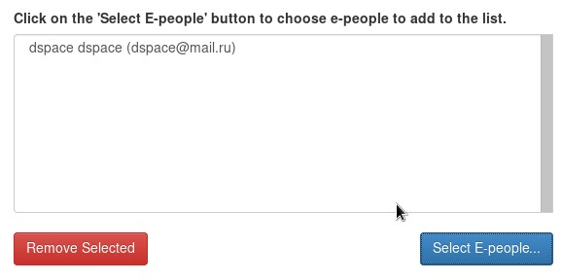

1. Now we move on to groups

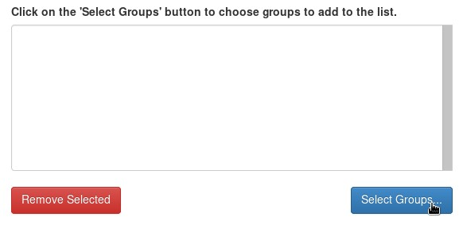

We select the needed groups of users in the newly-appeared window. In our case we choose all the available groups.

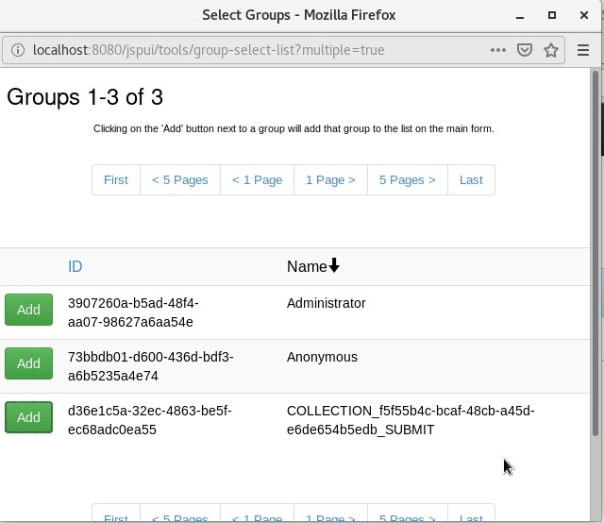

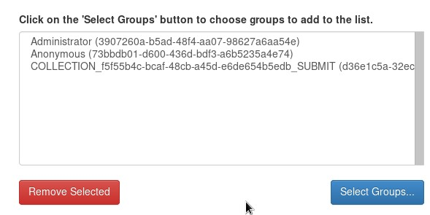

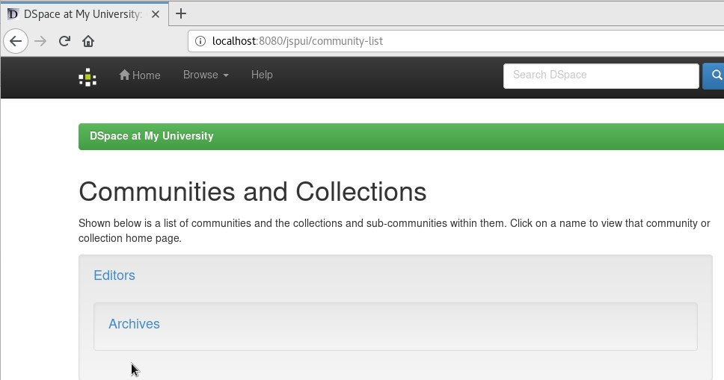

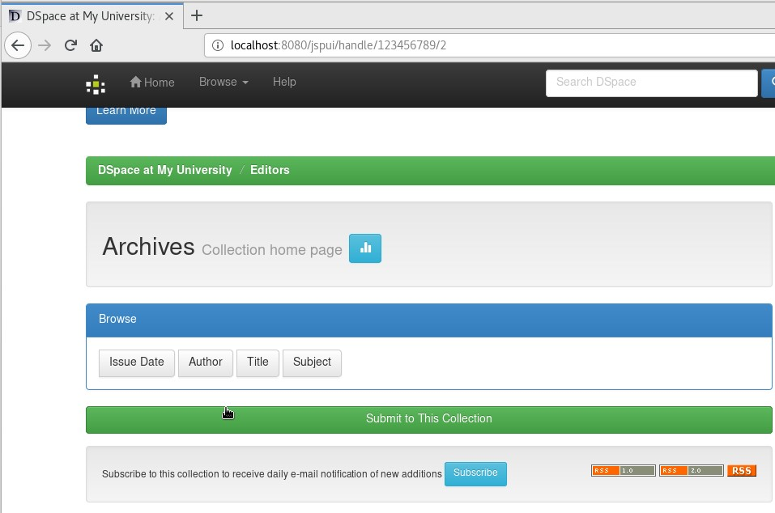

Now we go to localhost:8080/xmlui on a new tab.

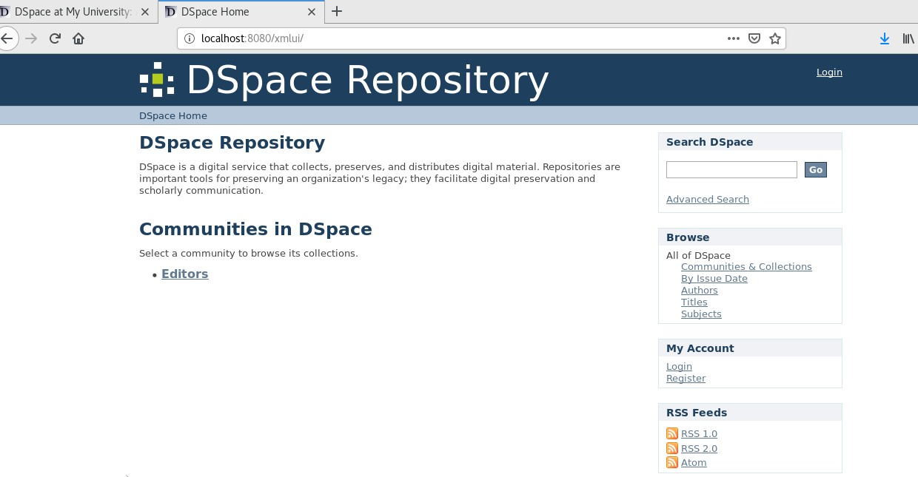

We sign in here as well.

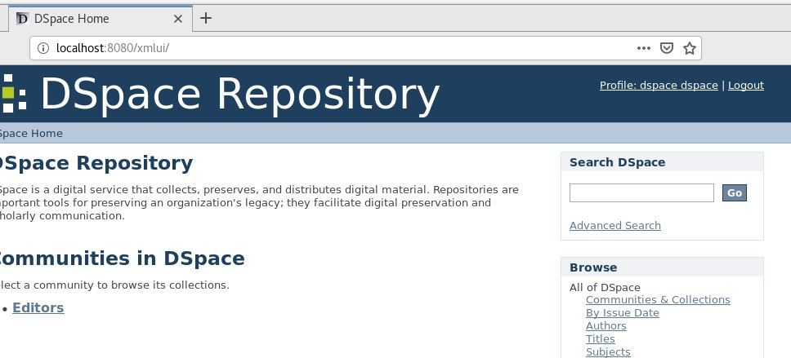

We import our zip file by clicking Batch Import (ZIP) on the Administrative panel and the Content Administration submenu.

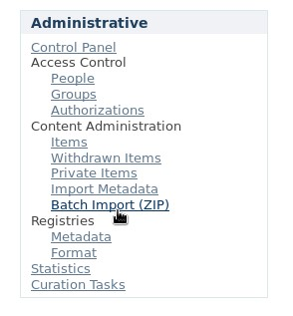

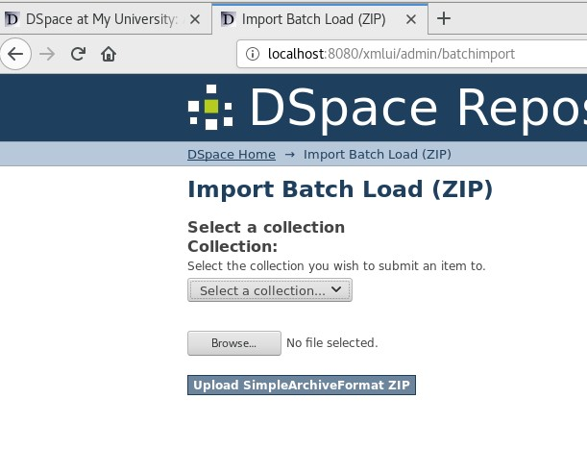

In the “Select a collection” window we select the collection created by us and upload the file from our computer with “Browse” and click “Upload SimpleArchiveFormat ZIP”

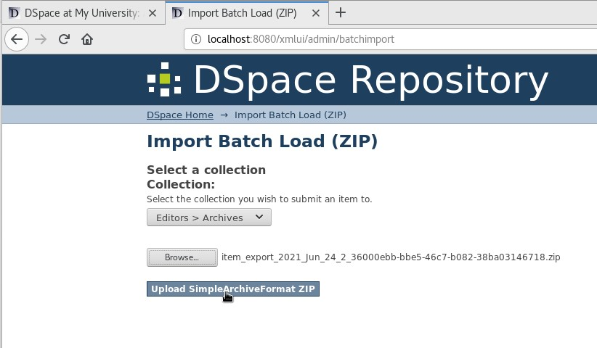

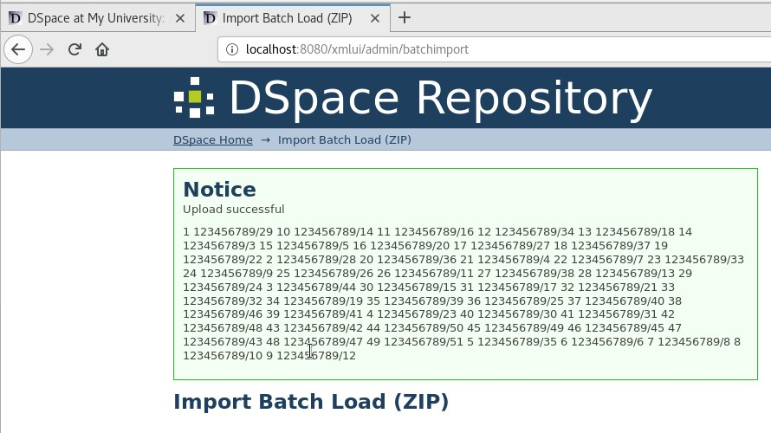

We go to localhost:8080/jspui and our Collection

